**Z-Tech Web-based eCommerce System**

**Proponent Names:**

**Keyan andy, delgado**

**Junggay, Juneil**

**Ogatis, Jener Kevin**

**jimbo, ulama**

**abdul, aziz marot**

**CHAPTER I**

**INTRODUCTION**

**Rationale of the Study**

This study aims to develop and implement the Z-Tech: A Web-Based E-commerce System, an online platform for purchasing computers, that will cater to a specific local area. The system will be designed to provide an easy and convenient way for customers to browse and purchase computer products without the need for physical store visits. A system is a set of interrelated components working together to achieve a specific goal or objective. In this case, the Zyrus Tech Web Application will be developed as a system that will provide a streamlined process for customers to purchase computer products. It will be designed to simplify the purchasing process by providing a user-friendly interface that will allow customers to browse, select, and purchase items with ease.

Z-Tech web is a small computer shop that has been operating for several years. It caters to customers in a specific local area and provides them with a range of computer-related products and services. As a small business, Z-Tech faces various challenges, including maintaining accurate records, managing inventory, and tracking customer orders. Currently, the process of selling products in Z-Tech involves a manual and paper-based system. Customers place orders for specific items, and the staff manually checks the inventory to confirm availability. Once confirmed, the staff then prepares the order and requests payment. This process can be time-consuming and prone to errors, especially when managing a high volume of orders. Additionally, the shop relies solely on walk-in customers as they do not have an online presence, which limits their potential market reach. To address these issues, the development of a web application for Z-Tech would streamline the ordering process and increase the efficiency of the business. A web application is a software program that runs on web servers and can be accessed using a web browser. By implementing a web application, Z-Tech can offer customers an easier way to place orders and access product information. The application can also assist with inventory management, sales tracking, and payment processing. Overall, the development of the Z-Tech web application will not only improve the efficiency of the business but also enhance the customer experience. By providing a more streamlined and accessible way to order products and services, Z-Tech can expand its customer base and increase revenue.

Z-Tech is having limited reach of their physical location. They are typically confined to a specific geographical area and can only cater to customers within that region. This can severely limit their potential customer base and make it challenging to expand their business. Another issue they encountered was the manual process of recording sales transactions and managing inventory. This process was time-consuming and prone to errors, which affected the accuracy of their records and caused discrepancies in their stock levels. In addition, they experienced difficulty in keeping up with the competition, particularly with the rise of e-commerce platforms. Without an online presence, they were at a disadvantage and struggled to attract new customers and retain existing ones. These problems not only affected their sales performance but also impacted their overall business operations. Thus, the development of the Zyrus Tech web application aims to address these issues and improve the efficiency and effectiveness of their sales process.

Z-Tech: A Web-Based E-commerce System provides several benefits to its users. (1) Firstly, it offers convenience by providing an easy and efficient way for customers to buy computers without leaving their homes. This can be particularly useful for customers who live far from computer stores or have busy schedules. With just a few clicks, customers can browse through the available computers, compare prices and features, and place an order for the one they like. (2) Additionally, Z-Tech Web Application offers cash on delivery payment, making the buying process even more convenient for customers. Customers can easily access complete and transparent information about the computers they sell, including specifications, prices, and customer reviews. This can help customers make informed decisions and choose the best computer that fits their needs. By providing this information, Z-Tech Web Application can establish trust with its customers and differentiate itself from competitors. (3) Z-Tech Web Application aims to provide an administrative panel for Z-Tech’s staff that will enable them to manage the products, orders, and customer information in real-time. This can help the staff of Z-Tech to easily monitor all the available products and orders of customers in real-time. (4) Z-Tech Web Application also aims to provide the sales for the days, weekly and monthly. This will help the staff on monitoring the sales of Zyrus Tech daily, weekly, and monthly. (5) Lastly the Z-Tech Web Application will be able to generate reports of the sale. This will give the company copies of sale in case the system crashes or causes an error.

This study was proposed to enhance the sale of Zyrus Tech and give customers a more convenient way of ordering. This will also help the staff of Zyrus Tech on monitoring and managing products, orders, customer information, and sales of the company. With the help of Zyrus Tech Web Application, it will increase the sales of Zyrus tech and will also attract more customers, because it gives a more convenient way of purchasing products that they want even without going out or coming to the store.

In conclusion, the study on Zyrus Tech's web application showcases its strengths in terms of functionality, user experience, performance, reliability, secure payment, and scalability. By addressing the problem that the Zyrus tech faces, Zyrus Tech can continue to enhance their web application and provide an exceptional user experience to their customers.

**Objectives of the Study**

**General Objectives**

This study aims to study and develop Zyrus Tech Web Application.

**Specific Objectives**

* To be able to design and develop an online platform for Zyrus Tech that will allow customers to browse and purchase available computer products.
* Implement a use-friendly interface that simplifies the browsing and purchasing process for customer, ensuring a seamless and enjoyable shopping experience. Focus on intuitive navigation, clear product description, and an easy-to-use checkout process.
* To be able to create an administrative panel for Zyrus Tech's staff that will enable them to manage the products, and orders in real-time.
* Add sales for the day, weekly & monthly.
* Present sales reports using visually appealing bar graphs for easy interpretation.

**Scope and Limitations of the Study**

**Scope of the study**

**Product browsing**

The web app will have a user-friendly interface with categories, and filters to help customers find what they are looking for quickly. Each product on the web app will have a detailed description and high-quality images to provide customers with a clear idea of what they are ordering.

**Secure payment**

The web app will offer cash on delivery, Customers will be able to pay when their order arrives, making the purchasing process more convenient for them.

**Administrative panel for staff**

The web app will provide an administration for Zyrus tech’s staff that can help them on managing every product, orders, and customer information all the time with ease.

**Sales**

The web app will be able to provide daily, weekly and monthly sales of the company. With the help of the web app the staff won't be needing to do manual tasks on recording the sales every day.

**Reports**

The web app will be able to generate reports of sales and order information every day. This will benefit the company by making a copy of records where they can hide encase if the web app crashes or causes errors

**Limitations**

**This study has the following limitations**

* The study will only cover the development and implementation of the web application for ZYRUS TECH. The study will not include the physical store and its inventory management.
* The web application will only cater to customers within a specific local area. Customers outside the coverage area will not be able to access the online platform.
* The study will not cover the marketing and advertising strategies of ZYRUS TECH. It will only focus on the technical aspect of the web application.
* The study will not include the development of a mobile application for ZYRUS TECH. The study will solely focus on the web application.

The scope of this study gives an overview of the online market system and a dashboard for the shop owner. Meanwhile, the limitations of the study set the boundaries of what will be covered and not covered in this study.

**Significance of the Study**

The Zyrus Tech Web Application is a significant contribution to the field of e-commerce, specifically in the area of online computer sales. The application provides a convenient and accessible platform for customers to purchase computers and computer-related products online, without the need to physically visit a store. This is especially relevant in the current global situation where there is a growing need for contactless transactions. The system is also beneficial for Zyrus Tech as it enables them to expand their customer base beyond their local area and reach customers nationwide. Moreover, the development of this system can serve as a basis for future research in the field of e-commerce and the implementation of similar systems in other small businesses. Overall, the significance of this study lies in its potential to enhance the efficiency and effectiveness of online transactions in the e-commerce industry, while also contributing to the growth and development of small businesses.

**Flow of the study**

**OUTOUT**

**PROCESS**

**INPUT**

* View Product information
* Add to cart
* Check Out
* Check Product Description
* Product information
* Total Payment
* Check product availability
* View product and order
* Total payment
* Update product
* View daily, weekly, monthly sales
* Calculate sales
* View most soled product
* Track sale
* View total sales

*Figure 1.1: Flow of the study of Zyrus Tech Web App*

**DEFINITION OF TERMS**

* **Inventory -** a complete list of items or products that a business has in stock and available for sale or distribution.
* **Local area -** a limited geographical region or area, typically within a city or town.
* **Purchasing -** the act of acquiring goods or services in exchange for money or other forms of payment.
* **Small business -** a privately owned and operated business that has a small number of employees and relatively low sales volume.
* **Web application -** a software application that is accessed through a web browser over a network, such as the internet.

**CHAPTER II**

**REVIEW OF RELATED LITERATURE AND STUDIES**

**Related Literature**

**Local literature**

**iJuanaHelpMo: Web and Mobile Application**

**for Reporting Violence: A Framework for**

**Developing Violence Against Women**

**Application**

According toFrancis F. Balahadia and Zerah-Jane M. Mortel(July 25, 2020) This study presents the development of a web and mobile application for reporting violence against women (VAW) in a discreet manner. It incorporates a customizable e-reporting mechanism and provides essential information about the laws and rights of women under Republic Act No. 9262. The research involved literature reviews, benchmarking of existing applications, and interviews with Gender and Development (GAD) offices in Laguna District IV, Philippines. The Agile Methodology was utilized for software development, encompassing stages such as planning, requirements analysis, design, testing, evaluation, and deployment.

The study serves as a valuable tool for raising awareness and preventing VAW incidents. It facilitates support for victims by assisting government agencies in formulating effective policies and activities. The proposed framework aims to enhance women's well-being and knowledge of their protection rights, increase the reporting of VAW cases, and enable swift contact with family or relatives during emergencies. Additionally, it offers the benefit of a centralized database for VAW cases, benefiting the Province of Laguna and various relevant organizations, including Provincial GAD, PNP-Women Desk, DILG, DSWD, and LGUs.

**Dr. Speaks: A Mobile and Web Application Framework for Filipinos with Verbal Apraxia**

According to Alfonso Miguel B. Oredina, Cerceas S. Bulawan and Emeliza R. Yabut (12 December 2021) Childhood apraxia of speech (CAS) is a condition in which children have trouble creating speech sounds and connecting them together in the correct order to form words. Speech-Language Pathologists use different treatment methods and tools for therapy sessions. However, most of these tools are written in the English language, making it difficult for Filipino students to understand. Because of language barriers and cultural differences, it causes confusion and delays their improvement. This study focuses on the development of mobile and web applications for Filipino children to practice their communication skills using the native language Tagalog. It contains different images and videos as visual representations to help students envision the words being spoken as well as audible sound practice sets. Furthermore, the Speech-Language Pathologists and Parents can monitor the child's progress with scores and audio recordings to assess the child's development.

**Foreign literature**

**Application of Software Engineering in Intermediate and Higher Education through Web Apps Development**

According to Christopher Rafael, Philipus Wijaya Adikusumo and Ngurah Agus Bangkit Sanjaya(12-13 October 2021) The development of software engineering has helped a lot of human work and made technological growth around the world. Software engineering can be applied to support various fields of work including education. The purpose of this research is to develop a web-based educational application that aims to improve online learning for students. There are several methods used to make this research, namely observation, research survey, industry survey, literature review, data analysis, and others. This research opens up various learning opportunities, especially during this pandemic, where every student must study at home. There are several steps in the development of this webapp, namely creating a conceptual design, frontend website, backend website, database, and security. Developing a WebApp to accommodate the studies of students will have an important role in the future with technological advancements. Online studies will help students study more efficiently without the need to bother with location and time. The result of this research will be a fully functional WebApp to assist students in online study for high schoolers and university.

**Design Thinking and Emotional Intelligence in UI/UX Design of Website-Based Online Foreign Service Travel Expenses (BPDL) Applications**

According to Radius Tanone and Wijayanti (09 November 2021) UI/UX design in applications is very important because a good design can meet user needs and make users feel comfortable and understand the use of the application. An example is an online application for website-based Foreign Service Travel Expenses (BPDL). In making this application focused on potential users of this application, if the user cannot understand the application created, it will have an impact on the user and the system. Such as data entry errors in the service application process, wrong service timings, etc. The purpose of this UI/UX design is to overcome any problems that may arise. When implementing this design, the design thinking method used can influence the way decisions are made, generate new innovative ideas, and make it easier for users to use BPDL applications.

**Local study**

**SimboWika: A Mobile and Web Application to Learn Filipino Sign Language for Deaf Students in Elementary Schools**

According to Herson Dave A. Vega, Raniel Cyrus L. Echon and Nico Ace A. Empe (3 December 2020) The communication between deaf and hearing people is hard especially when you consider the lack of technology and knowledge on language that the deaf people use. The population of the Philippines is increasing and so are the deaf people. The communication gap between these people are also expanding. English is the commonly use language by most people with hearing disabilities. American Sign Language (ASL) is considered as a renowned sign language in the Philippines but this is not the official language of the country. Most Filipinos are not aware of the existence of Filipino Sign Language (FSL). This is an American Sign Language-inspired and designed specifically for Filipinos. Deaf students in one elementary school in Manila were confused in learning Tagalog words because the sign language that had been established back then was American Sign Language (ASL). With this drawback, the researchers aimed to develop “SimboWika”, a mobile application to help the deaf students in elementary schools to learn Filipino Sign Language. It provides illustrations to practice FSL and assess student's learning. The teachers can also keep track of the student's progress using its web application. Based on findings, the SimboWika app got a Very Satisfactory result from the users and technical evaluation.

**INCOURT: a Web-Based Court Reservation and Scheduling Application for Barangay Kalaklan, Olongapo City Using Progressive Web Framework**

According to Charie Ignacioand Denise Lou Punzalan (May 10, 2023) People currently live in a totally different world than they did years ago, thanks to technological advancements. Technology is one of the most essential ways we have an impact on the planet. The development of web-based applications has progressed to the point where almost all organizations now operate in a paperless environment. Many organizations and agencies have transitioned from manual to computerized systems. Technology has become a big impact of advancement in today’s world. It helps modern world to become more efficient and raise productivity, inclusivity of services and improve overall well-being. “INCOURT” wants to make it easier to reserve the court in Kalaklan for the players who want to make a reservation without having to leave their home. And, for the barangay administrator, they will no longer do manual checking of reservations and there will be no conflict with the schedule of those who reserved the court. InCourt is an online court reservation web application in barangay Kalaklan. This enables barangay administrators to monitor and to view the reservation information, as well as properly manage those who made reservations. Also, for the players or event’s organizers who want to book the court without having to go to the barangay. This website will help both the Kalaklan personnel and players to reserve and monitor their own schedule. This website application will be beneficial to both players and those looking to reserve or learn more about a court in Kalaklan. This innovative system will assist the barangay of Kalaklan in reserving its basketball court.

**Foreign study**

**Online circular contrast perimetry via a web-application: ptimizing parameters and establishing a normative database**

According to Deus Bigirimana, Lazar Busija and Simon Edward Skalicky(16 May 2022) This study aimed to establish a normative database and optimize parameters for personal-computer-based perimetry using a web application with circular contrast targets. The perimetry test was conducted online, delivering stimuli through circular flickering contrast targets. Relative decibel (rdB) values were calculated based on contrast differentials embedded within the targets. A staircase system with reversals was employed to determine the rdB levels. Gaze was maintained on a spinning golden star to maximize sampling area, and blind spot localization was used to optimize viewing distance and count fixation losses. The test was performed by 158 eyes of 101 patients, with an average age of 62.9 years. Mean sensitivity decreased with age at a rate of 1.0 relative decibel per decade. The sensitivity per locus showed a physiological hill of vision and correlated with standard automated perimetry (SAP), with a mean difference of 4.02 decibels and good agreement between the two tests. In conclusion, online circular contrast perimetry provides accurate results comparable to standard automated perimetry, making it a reliable method for perimetric testing.

**Technology-Based Trainings on Emotions: A Web Application on Earthquake-Related Emotional Prevention with Children**

According to **Daniela Raccanello, Giada Vicentini** and **Margherita Brondino** (25 June 2019) In light of their potential for learning and engagement, using technology-based programs can be particularly relevant to enhance children’s emotional competence, also in relation to traumatic events such as disasters. Some studies investigated the efficacy of technology-based interventions fostering this ability, focusing on its different components, with different populations, and using different designs, but they did not relate specifically to disasters such as earthquakes. Nevertheless, in everyday life knowledge on earthquakes can be promoted through the use of mobile applications. We searched electronically all the applications present within the Google Play Store, identifying 20 applications on earthquake prevention. None of them was specifically focused on earthquake-related emotional contents, but some of them included some emotional elements. Therefore, to fill in the gaps in the current psychological literature, we developed a web application to promote earthquake-related emotional knowledge, to be tested in the future according to the standards of evidence-based research.

**CHAPTER III**

**RESEARCH METHODOLOGY** **AND DESIGN ENVIRONMENT**

In this chapter, the research methodology and design employed in the study on Zyrus Tech's web application. We describe the specific research objective and the overall plan for the study. Participants will be carefully selected based on relevant criteria, and data collection methods such as user testing, surveys, and interviews were utilized. The collected data will be analyzed using appropriate techniques to draw meaningful conclusions. Ethical considerations were taken into account throughout the study to ensure participant privacy and data protection. This chapter provides a comprehensive overview of the research approach used, setting the foundation for the subsequent analysis and findings.

**Environment**

The study on Zyrus Tech's web application will be conducted with real users in their everyday environments. Participants will use the application on their own devices, like phones or computers. Data will be collected through online surveys, interviews, or usage tracking. The study will last for a few weeks, and ethical guidelines were followed to protect participant privacy and obtain consent.

**SOFTWARE ENGINEERING METHODOLOGY**

**Figure 3**

Agile Development Methodology

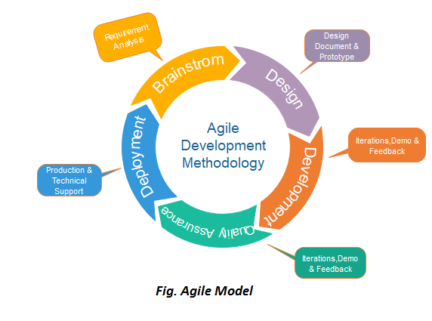

*Figure 3.0* *Agile Development Methodology of Zyrus Tech Web App*

Agile development methodology aligns well with the dynamic and evolving nature of web application development, enabling Zyrus Tech to deliver a high-quality product that meets client expectations, adapts to changes, and provides value to end-users.

**SYSTEM DEVELOPMENT**

**First phase of Methodology**

In the requirements analysis phase using Agile methodology, researchers follow a series of processes to gather, analyze, and document requirements. They work closely with the owner to capture requirements as user stories or items in a backlog, representing specific features or functionalities. The researchers prioritize these user stories and plan the content and duration of each sprint, which is a short development iteration. During sprints, the researchers collaborate closely with the owners, developing and delivering incremental features while gathering feedback. They hold daily stand-up meetings to provide updates, discuss challenges, and align efforts. Continuous feedback from the owner is sought to validate assumptions, make adjustments, and ensure that the developed features meet requirements. Regular integration and testing are conducted to ensure proper functionality, and at the end of each sprint, a review is held with stakeholders to demonstrate completed work and gather feedback. A retrospective meeting is also conducted to reflect on the sprint and make improvements to the development process. These processes allow researchers to effectively analyze requirements and develop a web application that meets stakeholder expectations in an iterative and collaborative manner.

**Second Phase of Methodology**

In the Design and Planning phase of Agile development, researchers focus on translating the gathered requirements into a detailed design and creating a plan for the development process. They begin by defining the overall architecture and high-level design of the web application, determining the system components and their interactions. Researchers then delve into the detailed design phase, creating specifications for each component or module, including database schema, user interfaces, APIs, and integrations. User interface (UI) design is also addressed, ensuring usability and visual aesthetics through wireframes or design mock-ups.

Technical and development planning is a crucial aspect of this phase. Researchers select appropriate technologies, frameworks, and tools while considering factors such as scalability, security, performance, and maintainability. They break down the design into smaller tasks, estimate the effort required for each, and prioritize them to create a development plan or schedule. Iteration planning further refines the plan by selecting user stories or tasks for each sprint, considering their priority, complexity, and dependencies.

Test planning is another key activity, ensuring a comprehensive strategy for testing the web application. Researchers define test scenarios, select appropriate testing techniques, and establish the necessary test environments and data. This planning phase sets the stage for subsequent development and testing phases, laying a solid foundation for efficient implementation. By focusing on detailed design, technical planning, development planning, and test planning, researchers ensure a well-structured and coordinated approach in moving forward with the Agile development process.

**Third Phase of Methodology**

In the Implementation phase of Agile development, researchers focus on the actual coding and development of the web application. They write code and develop the application based on the design specifications and user stories. Following coding standards and best practices, researchers utilize selected technologies and frameworks to implement the desired functionality. Task allocation is done to distribute work among the development team members, ensuring a balanced workload and efficient progress.

Collaboration and communication within the team are emphasized during this phase. Regular meetings and discussions help address questions, clarify requirements, and ensure a shared understanding of the tasks at hand. Continuous integration is employed, allowing the developed code to be frequently integrated into a shared repository or version control system. This practice helps identify and resolve conflicts or issues early on, promoting a smooth and cohesive development process.

Researchers follow an iterative approach, working in short development cycles or sprints. Incrementally developed features or functionalities are completed and delivered at the end of each sprint, facilitating continuous feedback and improvement. Quality assurance is integral, with thorough testing conducted during the implementation phase. Unit testing verifies the functionality of individual components, while integration testing ensures the proper interaction between different modules.

Bug fixing and refactoring are addressed promptly as identified during testing. Researchers resolve any bugs or issues and engage in refactoring to improve code structure, optimize performance, and enhance maintainability. Documentation is updated throughout the development process, capturing changes made, providing installation or deployment instructions, and updating user manuals or technical documentation accordingly.

By following these processes in the Implementation phase, researchers ensure the successful translation of design specifications into a functioning web application. Close collaboration, iterative development, and a focus on quality assurance contribute to the delivery of a high-quality and reliable end product.

**Next Phase of Methodology**

The Testing and Quality Assurance phase in Agile development focuses on thoroughly testing the developed web application to ensure its functionality, reliability, and adherence to the specified requirements. Researchers begin by creating a comprehensive test plan that outlines test objectives, scenarios, cases, and data. They execute planned tests, verifying the application's functionality, performance, and security. Defect management is crucial, with researchers tracking and prioritizing identified issues and collaborating with the development team to address and resolve them.

Regression testing is performed to ensure that fixes or changes made to address defects do not introduce new issues. User acceptance testing involves end-users or owners, validating the application's readiness for deployment through real-world usage simulations and gathering feedback. Continuous integration and continuous testing are emphasized, allowing for early issue identification and resolution.

Performance and security testing are conducted to assess scalability, responsiveness, resource usage, and overall application security. Throughout the testing phase, documentation is maintained, including test plans, cases, results, and defect records. Test reports are generated to communicate progress, coverage, and the application's quality to the owner.

By following these processes in the Testing and Quality Assurance phase, researchers ensure that the developed web application meets the required quality standards and performs as intended. Thorough testing, defect management, user feedback, and a focus on performance and security contribute to delivering a reliable and user-friendly final product.

**FUNCTIONAL DECOMPOSITION DIAGRAM**

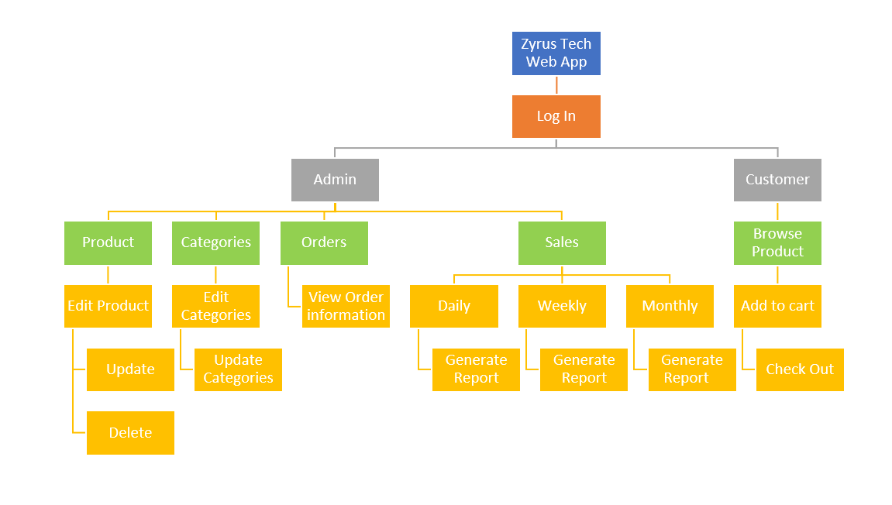

**ANALYSIS-DESIGN PHASE**

**USE CASE DIAGRAMS**

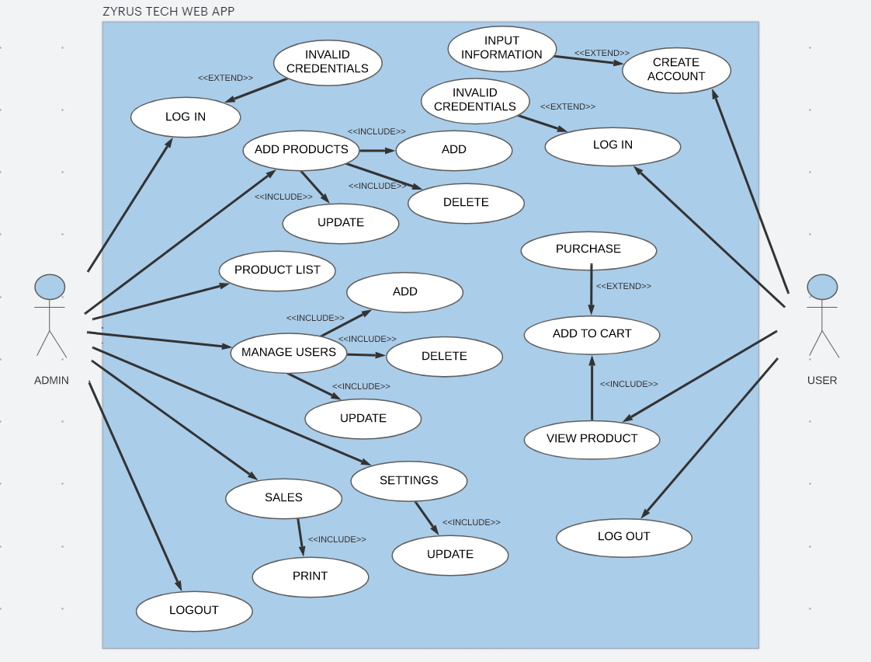

*Figure 3.3 Use case diagram of Zyrus Tech Web App*

**SEQUENCE DIAGRAM**

Add to cart

View Product

Purchase

Stock Item

Prepare ()

Check()

Condition

Prepare ()

*

Object

NeedsToReoder()

[check= ‘true’’]  
remove()

Iteration

Message

Self-Delegation

[needsToReoder =”true”  
new

return

A Reoder  
Item

Creation

A Delivery  
Item

[check= ‘true’’]  
new

[Check=’true’]new()

**SEQUENCE DIAGRAM- SYSTEM LOGIN**

[Result]

Validate

Login

ValidateUser

CheckUserDatails

[User Datails]

Users

Security Manager

Login Screen

Costumer

**Activity Diagram**

Customer Log in

Customer Input Email and Password

No

Yes

Customer Select Item

Customer receive message “Incorrect username or password”

System add selected items to cart

Decision Point: Are there more items to add

No

Yes

Customer add another item

Procced to check out

Procced to check out

System totals the order cost

Customer Provides delivery address and contact for COD payment

System Records the transaction

Z-tech delivery delivers the items

System Confirm that the item reaches the customer and the payment is successful

System Confirm that the item reaches the customer and the payment is successful

System Records The sale of the day

**Types of Requirements**.

* **Functional requirements**
* **User Registration and Authentication:**

Customers should be able to create accounts with unique usernames and passwords.

The system should provide authentication mechanisms to ensure secure access.

* **Product Browsing**

The system should have a user-friendly interface with categories and filters for product browsing.

Each product should have a detailed description and high-quality images.

* **Shopping Cart**

Users should be able to add products to their shopping cart.

The system should allow users to view and modify the items in their cart.

* **Order Placement**

Customers should be able to place orders securely.

The system should generate order confirmation emails for customers**.**

* **Payment Processing:**

The system should support secure payment methods, including cash on delivery.

Integration with payment gateways for online transactions should be implemented.

* **Administrative Panel**

The system should provide an administrative panel for Z-Tech staff.

Staff should be able to manage products, view and process orders, and access customer information**.**

* **Sales Tracking**

The system should record daily, weekly, and monthly sales.

It should provide a dashboard for staff to easily monitor sales performance**.**

* **Reporting:**

The system should generate sales reports using visually appealing bar graphs for easy interpretation.

Reports should include information about products, sales, and orders.

* **Security Measures**

Implement secure data transmission and storage practices.

Protect sensitive customer information and payment details.

* **Localization**

The system should cater to customers within the specific local area as mentioned in the scope.

Implement localization features if necessary, such as language preferences.

* **Accessibility**

Ensure the web system is accessible to users with disabilities.

Follow best practices for web accessibility standards.

* **Search Functionality**

Implement a search feature to help customers quickly find products based on keywords.

* **Feedback and Reviews**

Allow customers to provide feedback and reviews for products.

Display average ratings for products based on customer reviews.

* **Non-functional requirements**
* **Performance**

The system should load product pages within 3 seconds to ensure a responsive user experience.

It should handle a minimum of 500 concurrent users without significant performance degradation.

* **Scalability**

The system should be scalable to accommodate an increasing number of products and users.

It should handle a 20% increase in products and users over the next year.

* **Reliability**

The system should have an uptime of at least 99.9% to ensure continuous availability.

It should have a reliable backup and recovery mechanism to prevent data loss.

* **Security**

Implement encryption for data transmission to ensure secure communication.

Regularly update and patch the system to address security vulnerabilities.

* **Usability**

The user interface should be intuitive and user-friendly.

The system should be accessible to users with different levels of technical expertise.

* **Compatibility**

The web system should be compatible with major web browsers such as Chrome, Firefox, Safari, and Edge.

It should be responsive and usable on various devices, including desktops, tablets, and smartphones.

* **Scalability**

The system should be able to handle an increasing number of users and transactions as the business grows.

It should scale horizontally by adding more servers if needed.

* **Data Privacy and Compliance**

The system should comply with data protection regulations, ensuring the privacy of customer information.

Implement mechanisms to handle user consent for data processing.

* **Documentation**

Provide comprehensive documentation for system administrators and end-users.

Include user manuals, system architecture documentation, and troubleshooting guides.

* **Response Time**

The system should respond to user interactions (e.g., clicks, form submissions) within 1 second.

Ensure that all user interactions provide feedback promptly.

* **Capacity Planning**

Regularly assess system capacity and plan for necessary upgrades or optimizations.

Conduct capacity planning exercises to anticipate future resource requirements.

* **Backup and Recovery**

Implement regular backup procedures for the system data.

Develop and test a robust recovery plan in case of system failures.

* **Audit Trail**

Maintain an audit trail for critical system activities, including user logins, product updates, and order processing.

Ensure that the audit trail is secure and accessible only to authorized personnel.

**STORYBOARD**

**Admin/Customer Login Page**

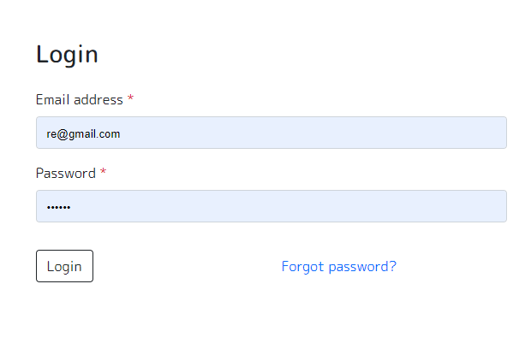

*Figure 3.4 Log in for Admin/Customer in Zyrus Tech Web App*

**Admin Sales Report**

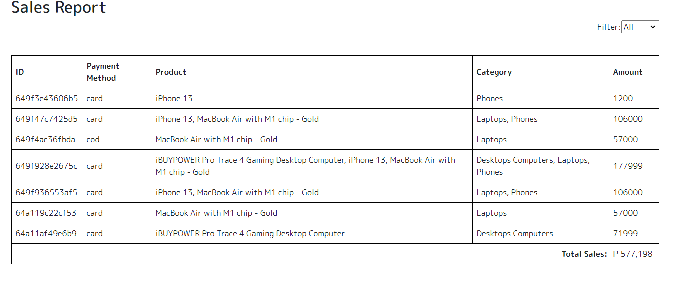

*Figure 3.5 Sales Report of Zyrus Tech Web App*

**Update Product**

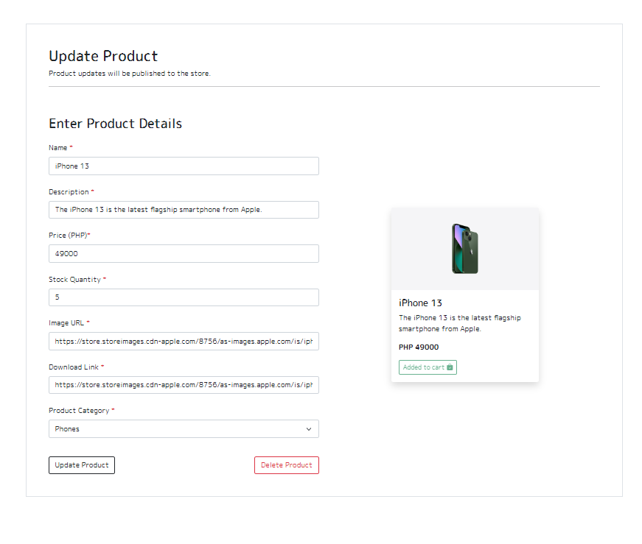

*Figure 3.6 Update Product of Zyrus Tech Web App*

**Orders**

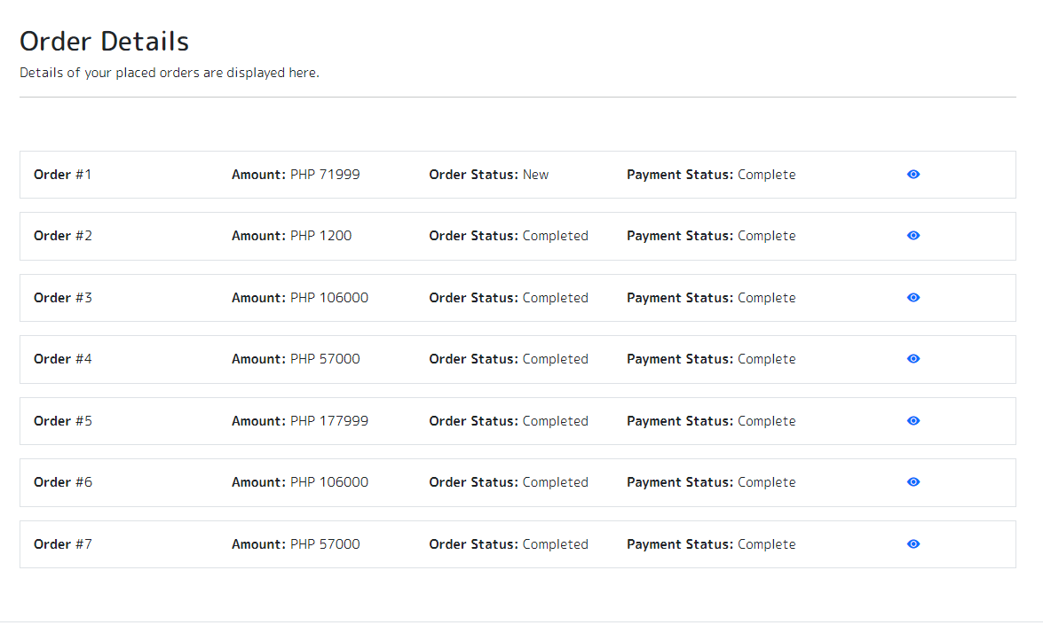

*Figure 3.7 Orders of the customer form Zyrus Tech Web App*

**Products**

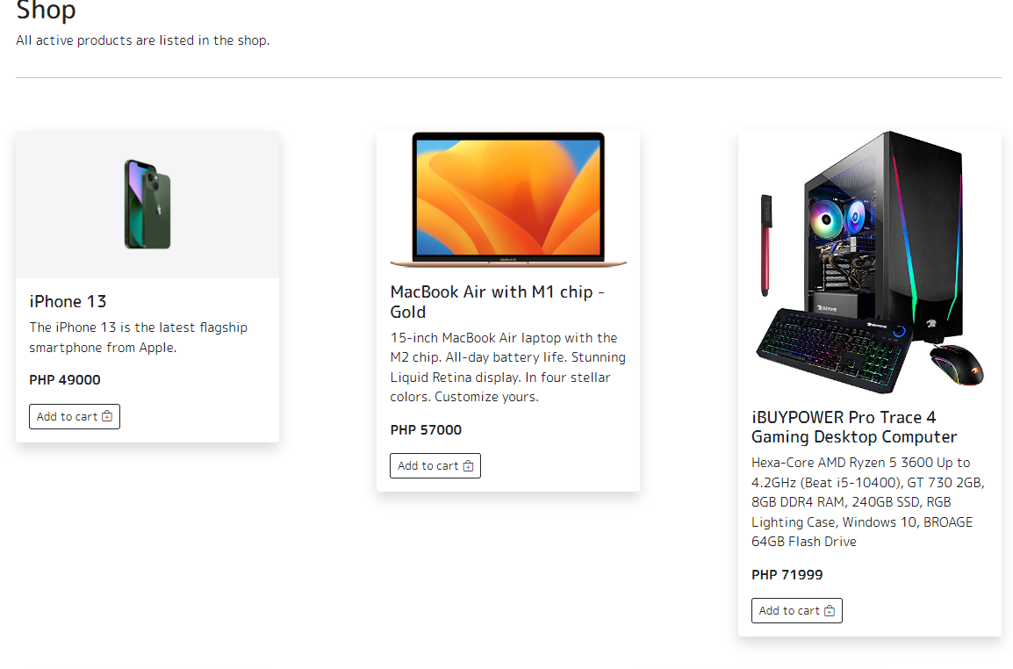

*3.8 Product of Zyrus Tech Web App*

**Check Out**



*Figure 3.9 Check out of customers’ orders*

**Conceptual framework**

Generate Reports

Purchase

Browse

Admin

Customer

User experience

Responsiveness

Accessible

Security

Service Quality

Z-tech: Web-Based E-commerce system

Response time

Manage Products

Manage Order

**Software Specification**  
**Language**: JAVA/CSS/PHP  
**Technology**: JAVA  
**Database**: MySQL XAMPP

**Hardware specification**  
1. **Processor**: AMD A8-9600  
2. **Hard Disk**: 1024 GB  
3. **RAM**: 16GB  
**Program Specification**  
**Language**: PHP  
**Database**: MySQL XAMPP Server  
**IDE**: Visual code